The easiest Gigabit service for events you’ve ever set up
Wireless solution delivers robust gigabit services to and inside the venue

Introduction
Convention centers are challenged to provide reliable Internet solutions for exhibitors and attendees inside their venues. For one, the floor plan is constantly changing and wires can be cut during set-up. For another, the high influx of show attendees makes reliable high-throughput Wi-Fi and cellular difficult to provide. Cellular and Wi-Fi usage rely on the same sub-6GHz bands which can cause mutual interference and performance degradation, and also preclude the use of sub-6 GHz wireless systems to provide connectivity for exhibitors.

On the other hand, exhibitors at shows are willing to pay for a broadband connection. However, they require extremely high reliability, demanding redundancy and even triple redundancy with high penalties for downtime.

Providing reliable broadband services during a show can be an extremely profitable revenue stream for venue owners, while also providing a strong competitive advantage. Any broadband service provided must be extremely resilient, both indoors and outdoors to avoid penalties.

For indoor connectivity a wireless solution can be beneficial because of a reduced risk of wire cutting, while allowing ultimate flexibility for placement and response times in minutes to changing demands. Any indoor wireless solution must be isolated from existing Wi-Fi and cellular solutions, and also be configured for high resiliency.

And when the capacity demands, or the required levels of redundancy, exceed the current availability for the entire venue, a mmWave wireless link can be deployed in hours to add capacity and reliability with throughputs of 10Gbs per link.

Siklu’s Broadband Solutions for Convention Centers

Multi-Gigabit to the Booths
Siklu’s solution for convention centers is MultiHaul™, a point-to-multipoint solution that operates over 60 GHz, a band that experiences no interference from Wi-Fi and cellular applications. MultiHaul™ delivers 1Gbps per end-point, which can be installed on walls or poles. The terminal units are tiny and unobtrusive, as small as a regular Wi-Fi router.

The Siklu MultiHaul™ is a nomadic wireless solution. No wires to run (or accidentally cut), just install the base units once, and setup terminal units anywhere services are needed, roughly pointing them towards a base unit. The system automatically sets itself up from that point. With an install time of 5 minutes, you can easily move it around for each event, or even during the event.

Most convention centers split the capacity up between booths using a switch per row, and typically provide 10, 20, 40 or even 100Mbps capacity per exhibitor or a full gigabit to the main stage. Typically, a positive ROI is achieved within a couple of shows.

Multi-Gigabit addition to the venue
Siklu outdoor radios provide up to 10 Gbps interference free connectivity. They can be used to add backup for your main fiber lines, and are installed in just a few hours. Operating over the lightly licensed 70/80 GHz bands, they are extremely reliable, and do not experience interference from other wireless systems. Combining throughput and reliability, Siklu radios help you expand capacity to the venue, or avoid downtime penalties due to outages on your main fiber lines.

Benefits
- Multi-gigabit capacity, as high as a gigabit indoors, and as high as 10Gbps outdoors
- Wireless systems that yield a positive ROI within a couple of events
- Easy to deploy indoors with automatic alignment and set-up
- No fear of cable cutting
- Highly reliable interference-free operation so you can guarantee capacity and avoid downtime penalties
- Operates in its own spectrum, won’t get jammed by heavy Wi-Fi or cellular usage
- Deploy anywhere indoors - ceilings or walls - or outdoors - street furniture or rooftops
- Small and unobtrusive

Solutions Details

Indoor Exhibit Connectivity
Siklu MultiHaul™ can deliver 1 gigabit throughput as far as 900’, more than enough to cover the largest exhibit halls. A typical set-up would include at least 2 MultiHaul™ base units (BUs), preferably located on the narrowest wall of the hall in order to cover the whole space. The terminal units (TUs) are placed where needed in the hall or on top of a booth.
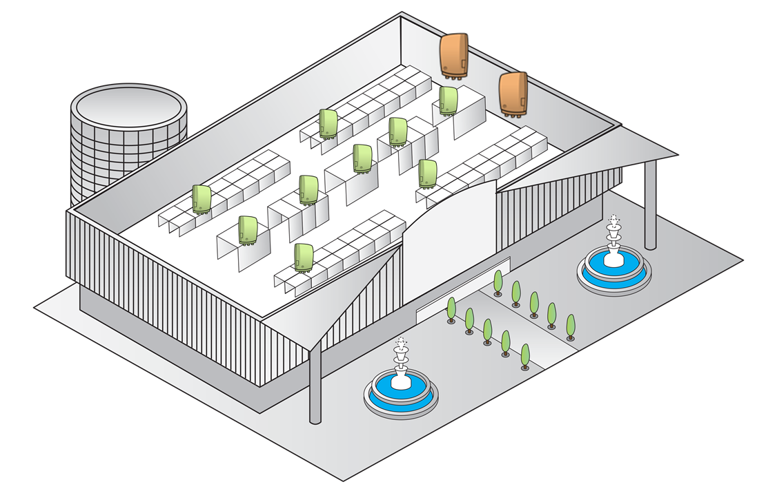
Figure 1: Indoor Wireless Gigabit configuration
Most convention centers split the gigabit capacity of a TU up between booths using an Ethernet switch per row, and typically provide 10, 20, 40 or even 100Mbps capacity per exhibitor. A multiport TU can also serve a gigabit to the main stage, a strategic exhibitor or a large booth on its own with a built-in 3-ports Ethernet switch and optional PoE (PSE). For high capacity configurations, the BUs are placed along the longer walls of the hall, spaced in order to guarantee coverage across the hall, as shown below.
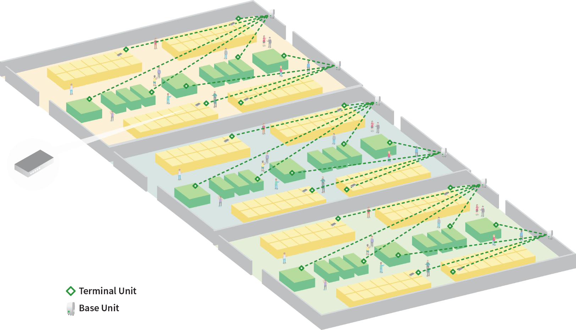
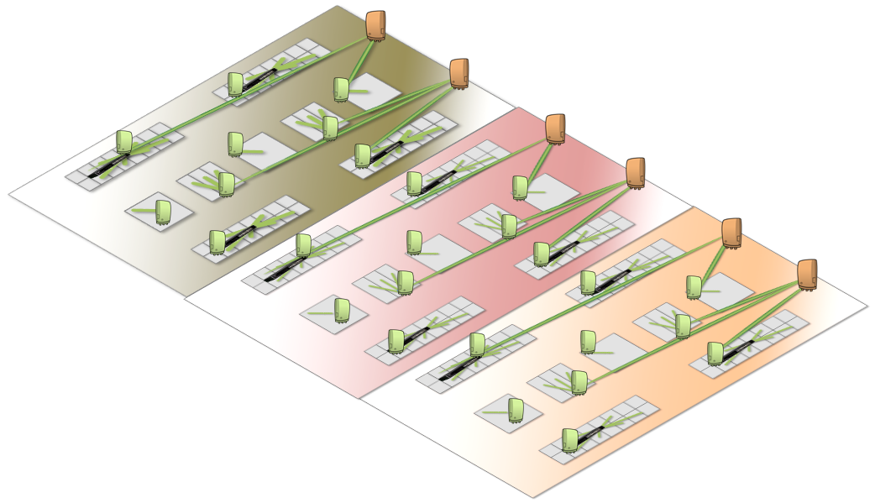
Figure 2: Indoor High-Capacity Wireless Gigabit configuration [replace drawing above by 3D view]
Total wireless capacity provided by a single BU is 1.8Gbps, shared dynamically between the TUs according to the needs of the applications in the booth. Each BU serves up to 8 TUs, with anywhere between 100M and up to 1Gbps of capacity. MultiHaul™ units are all powered by Power over Ethernet (PoE) as a Powered Device (PD), consuming 10W per unit, and an AC-mains power to PoE-injector is included with each unit.

The Base Units (BUs) connect to the main network connections in the data room with CAT-5e or fiber (single- or multi-mode). The TU installs and connects in minutes leveraging an electronically controlled beam-forming antenna which auto-aligns with the BU, creating a high-capacity narrow-beam which provides highly reliable performance.

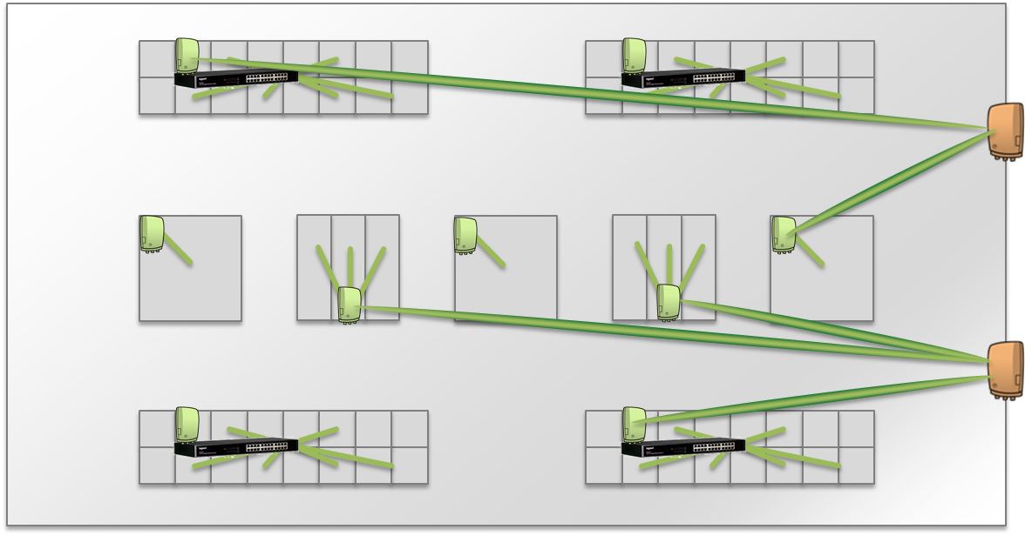
Figure 3: Millimeter waves narrow beams for high capacity
Where very tight service level agreements are required, it is possible to operate the base units in redundant mode to create physical layer redundancy which recovers the connectivity in seconds, autonomously.

In most cases, MultiHaul™ is configured once during initial setup and commissioning of the system; when needed, a powerful on-board web-server allows oversight, and a detailed SNMP MIB enables integration into the facility IT local management console.

Siklu MultiHaul™ system operates in the uncongested 60GHz spectrum, with wide channels of 2.1 GHz each. In fact, the 60 GHz alone has more bandwidth than all the Wi-Fi and cellular spectrum combined. The system uses proprietary beam-forming technology which provides 1 gigabit coverage for up to 900’ over narrow-beams, which improves spectrum utilization inside the facility and simplifies re-use planning when 3, 5 or 10 Gbps of total capacity are needed.
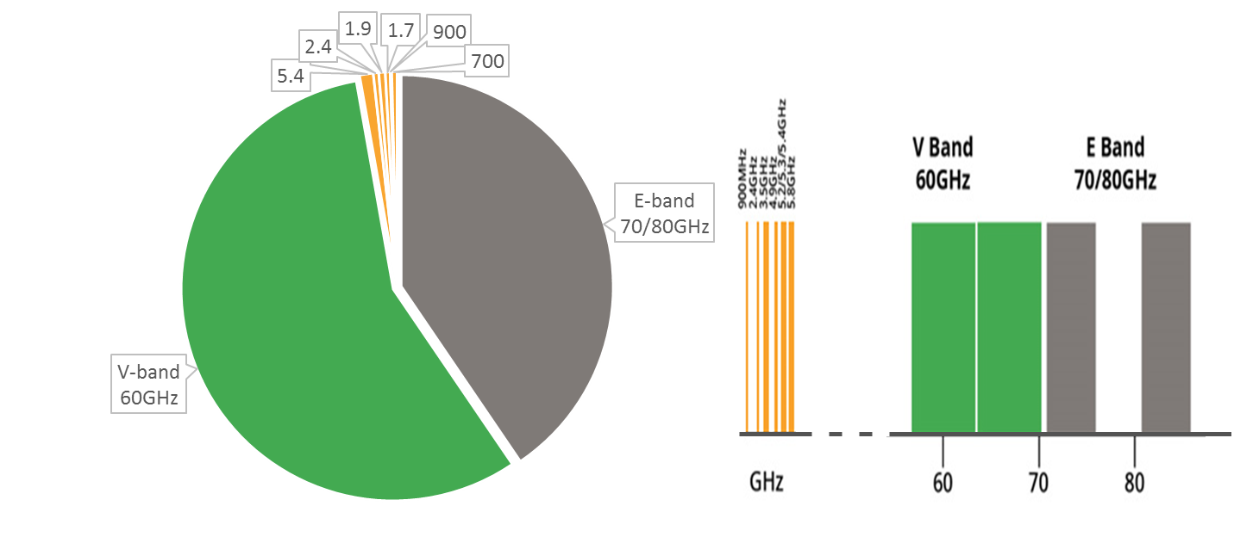
Figure 4: Millimeter Wave spectrum (60 GHz) is 1000x more plentiful, compared with Wi-Fi & Cellular

Interference Immunity & Dense Deployments
Siklu MultiHaul™ systems use of the 60GHz spectrum, which is 10x time higher than cellular and Wi-Fi systems commonly used around the exhibition center, results in operation that is free from interference from other networks, and is unaffected by their number of users or the amount of traffic. The MultiHaul™ provides a highly reliable service with performance comparable to fiber.
Figure 5: 60 GHz spectrum, 10x higher than Wi-Fi or cellular
The MultiHaul™ narrow beams can be steered easily by the internal antenna array to align and focus the base and terminal units. Whereas Wi-Fi systems beams are 30° degrees wide or more, MultiHaul™ beams are no wider than 5°, achieving high immunity to interference from neighboring units, providing an extreme advantage in dense deployments.

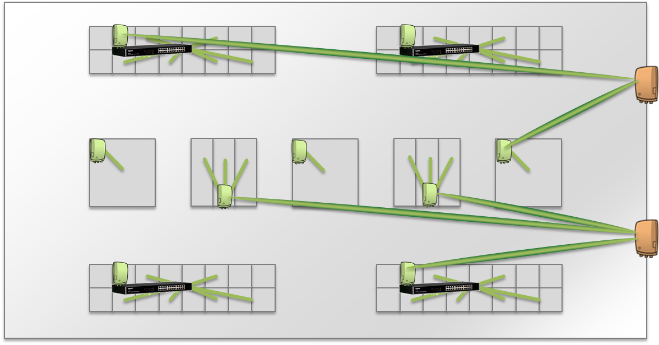
Figure 6: Millimeter waves narrow beams for high capacity
Connectivity to the venue: Capacity addition or Fiber Backup

A single EtherHaul™ wireless link delivers Ethernet capacity up to 10Gbps, with up to 2 links can be installed in 2+0 mode on a single antenna for redundancy. Operating in the 70 & 80 GHz spectrum, these wireless links deliver fiber-like capacity and similar availability, without a need for frequency surveys. With installation in hours, backup for an existing single fiber link can be added for specific events or permanently.
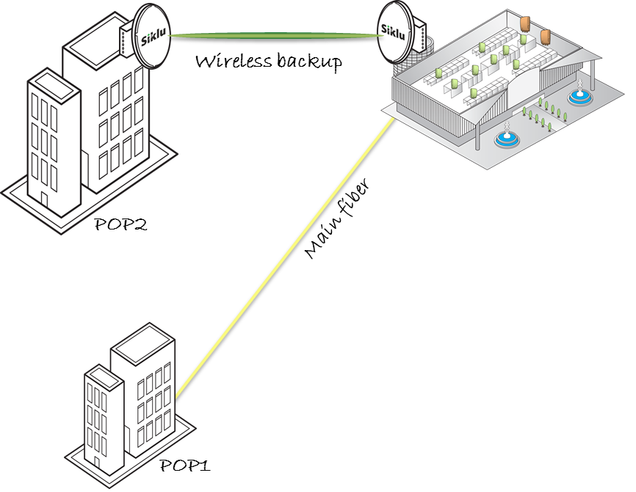
Figure 7: EtherHaul™ brings interference immune multi-gigabit capacity with narrow-beams

Siklu’s EtherHaul™ features:
- Up to 10 Gbps full-duplex Ethernet capacity on fiber ports (some models feature RJ-45 ports, depending on link capacity)
- Enhanced hitless Adaptive Coding & Modulation capabilities for fiber-like availability
- Small-size, low power consumption and high radio transmit power for extended reach
- Carrier-grade networking capabilities (some models)

Offering easy and low cost all-outdoor installation and commissioning in a small form factor, EtherHaul™ mmWave links boast a small system and antenna footprint, and especially low power consumption, under 50W per radio.

FAQ

What are millimeter waves?
Millimeter waves are a range of spectrum between 57-86GHz and are characterized by a very broad spectrum with wide channels that supports high throughput radios.

Do Wi-Fi and Cellular services interfere with Siklu's radios?
Siklu’s radios operate over millimeter waves, an entirely separate range of spectrum 10x higher than Wi-Fi and cellular. They simply cannot be impacted by these other systems.

What is automatic alignment?
Siklu’s MultiHaul™ utilizes unique beamforming antennas that automatically seek and connect the base and terminal units. There is no manual intervention involved.

How do I move units around for different events?
The units are associated together during the initial installation and commissioning on site. From that moment on, a MultiHaul™ TU can be moved from booth to booth between events, or even during an event and it will automatically reconnect upon power-up. A green LED on the side of the unit indicates that power is on, and another one confirms that the link up, no need for configuration. Up to 3 other LEDs indicate Ethernet connections.

How will I get power?
All Siklu radios are powered with Power over Ethernet. The indoor units consume generally about 10W, and the outdoor ones may need as much as 50W (model dependent).

How can I guarantee capacity?
Both EtherHaul™ and MultiHaul™ operate over uncongested millimeter wave spectrum, free from interference from other wireless networks such as Wi-Fi or cellular.

The MultiHaul™ base units can be configured in redundant mode to create physical layer redundancy which recovers the connectivity in seconds, autonomously.

For the connection into the venue, any EtherHaul™ radios can also be configured in a dual link redundant mode with automatic recovery.

What is the max capacity (convention center, booth)?
Indoors, each MultiHaul™ BU serves up to 1.8 Gbps and you can add as many as you need. Each TU serves up to 1 Gbps, which can be split with an Ethernet switch between the booths in the same row.

Outdoors, the EtherHaul™ systems deliver up to 10 Gbps full duplex.

How many booths can be connected?
The 1.8 Gbps capacity from the MultiHaul™ Base Unit can be divided to up to 8 Terminal Units, and those in turn can be divided into as many booths as needed using an Ethernet switch.

Are Siklu radios secure?
Because they operate over very narrow beams, hacking or jamming Siklu radios is virtually impossible. In addition, each radio has robust AES encryption to keep your network traffic secure.

About Siklu
Siklu delivers multi-gigabit fiber-like wireless connectivity in urban, suburban and rural areas. Operating in the millimeter wave bands, its wireless solutions are used by leading service providers and system integrators to provide gigabit services, 5G fixed wireless and in safe city and smart city projects. Thousands of carrier-grade systems are delivering interference-free performance world-wide. Easily installed on street-fixtures or rooftops, the price-competitive radios have proved to be ideal for networks requiring fast and simple deployment of secure and future-proof connectivity.www.siklu.com.

